

**FPT UNIVERSITY**

**Taxi Caller Application on Windows Phone**

**F_Taxi**

**Report #4 – Software Design Specification**

|  |  |
| --- | --- |
| F_Taxi | |
| Group Member | SE02705 - Phạm Gia Hữu |
| SE02900 - Tạ Thiên Hưởng |
| SE02268 - Phạm Ngọc Hoàn |
| SE02314 - Nguyễn Văn Lập |
| Supervisor | Nguyễn Văn Sang |
| Project Code | F_Taxi |

HaNoi, 11/2015

Table of Contents

1 Application Architecture Design 3

1.1 Three Layer Architecture 3

1.1.1 Three Layer Architecture Overview 3

1.1.2 Advantages and disadvantages 4

1.1.3 The reason of choice 5

2 Application Detail Design 5

2.1 Class Design 5

2.1.1 Rider 5

2.1.2 Driver 9

2.2 Sequence Diagram 12

2.2.1 Trip 12

2.2.2 Register 15

2.2.3 Login 16

2.3 Screen Design 16

2.3.1 Guest 16

2.3.2 Rider 18

2.3.3 Driver 35

3 Others 52

3.1 Notification on Windows Phone 52

4 Reference 52

# Application Architecture Design

## Three Layer Architecture

### Three Layer Architecture Overview



Three Layer Architecture is a hierarchical architecture that uses many layers for allocating the different responsibilities of a software product.

The system is decomposed into a number of higher and lower layers in a hierarchy; each layer consists of a group of related classes that are encapsulated in a package, in a deployed component, or as a group of subroutines in the format of method library or header file. Also, each layer has its own responsibility in the application.

The components in Three Layer Architecture:

* Presentation Layer: are user interfaces, is the form of interactive program with system user. This layer missions communicate with end users to collect data and display the results, the data through the objects in the user interface.
* Business Logic Layer: assigned to are processing layer the business of the program as calculating, processing requests and check the validity and integrity of the data before it put on display on the screen or data processing before moving down data Data Access Layer to save data to the database.
* Data Access Layer: the function of this layer are communicate with the management system database

In the F-Taxi application:

* Presentation Layer: using Telerik Controls to design some user interface. Bing map to display Maps and navigation with two main user. Google API. Notification to communicate with two kind of user Rider and Driver.
* Business Layer: using classes and object to work with T-Net, T-Net is a company supply web service and communicate with database.
* Data Access Layer: using local database.

#### Presentation Layer

* Presentation are user interfaces, is the form of interactive program with system user. This layer missions communicate with end users to collect data and display the results, the data through the objects in the user interface.
* In F-Taxi application : using Telerik Controls to design some user interface. Bing map to display Maps and navigation with two main user. Google API. Notification to communicate with two kind of user Rider and Driver.

#### Business Layer

* Business Logic Layer: assigned to are processing layer the business of the program as calculating, processing requests and check the validity and integrity of the data before it put on display on the screen or data processing before moving down data Data Access Layer to save data to the database.
* In F-Taxi application : using classes and object to work with T-Net, T-Net is a company supply web service and communicate with database.

#### Data Access Layer

* Data Access Layer: the function of this layer are communicate with the management system database.
* In F-Taxi application: using local database

### Advantages and disadvantages

* Advantages :
  + The maintenance of your application is easier because of the low coupling between layers.
  + Adding more functionality to your application is made easier.
  + Layers make your application more testable.
* Disadvantages :
  + It is difficult to exactly assign of functionalities to the correct and appropriate layer
  + Negative impact to the performance of system

### The reason of choice

- Easily in develop and maintain system due to high flexibility, scalability and maintainability.

- Better support for test-driven development.

- It is good support for application built by project team has not too much developers thanks to the ease of reusability.

# Application Detail Design

## Class Design

### Rider

#### Get List Favorite Driver

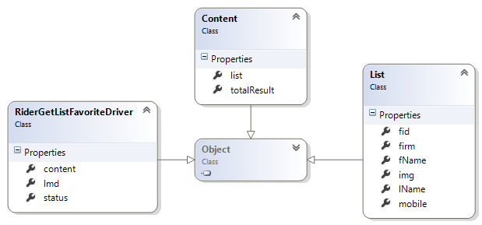

#### Convert Data

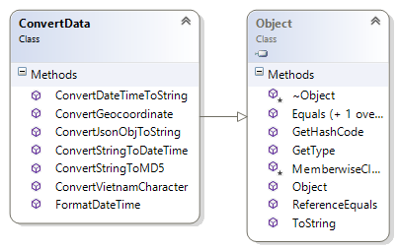

#### Get City List

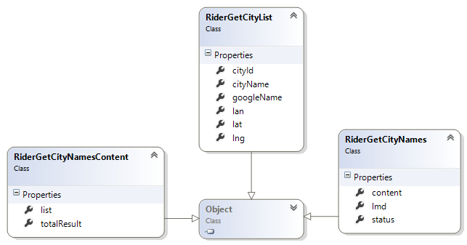

#### Get My Trip

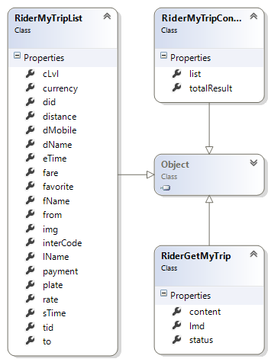

#### Get Near Driver

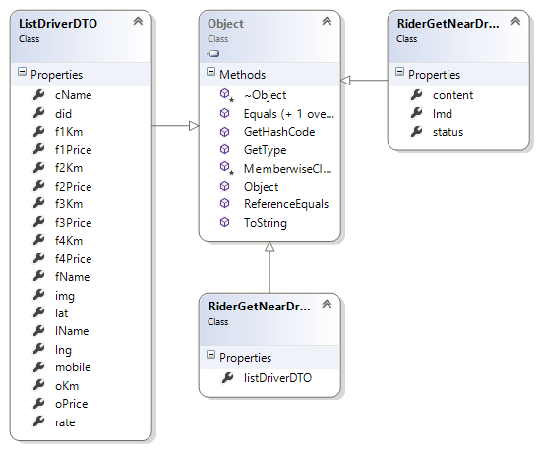

#### Register

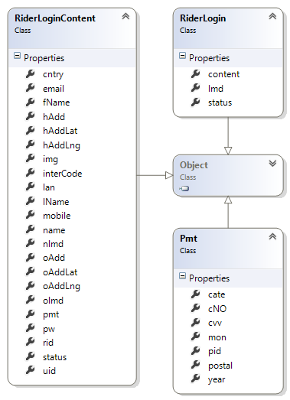

### Driver

#### Login

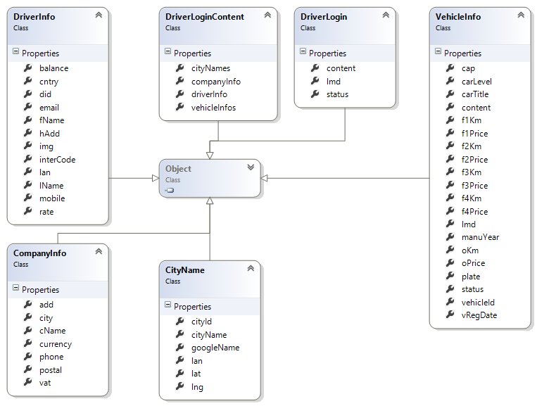

#### Accept Trip

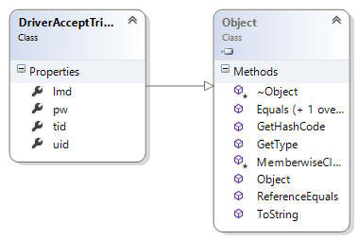

#### Complete Trip

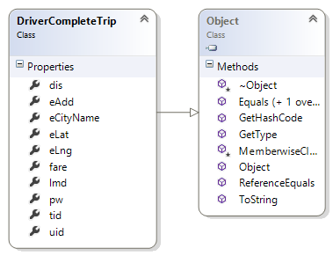

#### Notification New Trip

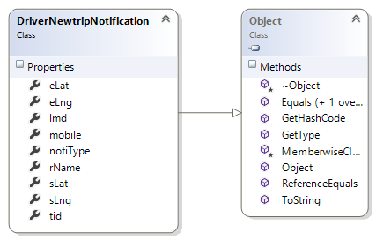

#### Notification Update Trip

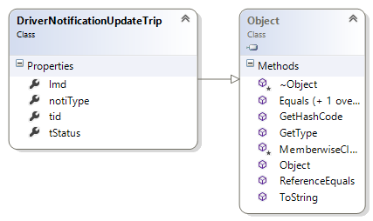

#### Select Available Vehicle

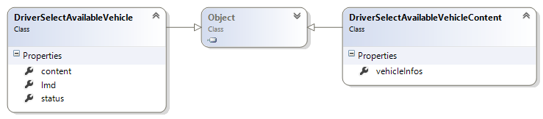

## Sequence Diagram

### Trip



### Register



### Login



## Screen Design

### Guest

#### FirstPage



|  |  |  |
| --- | --- | --- |
| Element | Type | Description |
| Bỏ qua để bắt đầu | Button | Show Login Page |
| Ảnh | Image | Show Introduction of application |

#### Register



|  |  |  |
| --- | --- | --- |
| Element | Type | Description |
| Email text field | Edit text | Enter Email |
| Mật khẩu text field | Edit text | Enter Password |
| Nhập lại mật khẩu text field | Edit text | Enter Confirm Password |
| Tên text field | Edit text | Enter Last Name |
| Họ text field | Edit text | Enter First and Middle Name |
| Số điện thoại text file | Edit text | Enter Phone Number |
| Đăng ký | Button | Register new user as Rider |

### Rider

#### Login



|  |  |  |
| --- | --- | --- |
| Element | Type | Description |
| F-Taxi | Image | Logo F-Taxi |
| Tài khoản text field | Edit text | Enter Email |
| Mật khẩu text field | Edit text | Enter Password |
| Đăng nhập | Button | Tap button for logging in application |
| Đăng ký | Button | Tap button for register screen |
| Quên mật khẩu | Label | Tap label for showing forget password screen |

#### Lost Password



|  |  |  |
| --- | --- | --- |
| Element | Type | Description |
| Email text field | Edit text | Enter Email |
| Đặt lại mật khẩu | Button | Tap button for send password to email user |

#### Home Page

##### Home Page



|  |  |  |
| --- | --- | --- |
| Element | Type | Description |
| Map | Map | Show map |
| Taxi Image | Button | Clickable button for show Trip bar |
| Chọn điểm đón | Button | Clickable button for choose pick up position |
| Menu | Menu | Show left menu |
| Địa chỉ đón text field | Edit Text | Text field to enter keyword to search |
| Marker | Image | Always on middle of screen for user choose pick up position |
| My position | Image | Show current user position |
| Taxi icon | Button | Clickable button for show kind of taxi |

##### Home Page with Trip bar







|  |  |  |
| --- | --- | --- |
| Element | Type | Description |
| Map | Map | Show map |
| Taxi Image | Button | Clickable button for show Trip bar |
| Menu | Menu | Show left menu |
| My position | Image | Show current user position |
| Địa chỉ đón text field | Edit Text | Text field to enter keyword to search |
| Giá mở cửa | Text | Show open price |
| Phí ước tích | Text | Show estimate payment price |
| Điểm đón | Text | Show pick up position |
| Điểm đến text field | Text edit | Text field to enter keyword to search |
| Ảnh (tên lái xe) | Image | Show driver information |
| Mã khuyến mại | Text edit | Enter field for discount trip |
| Tự động gọi xe khác khi bận | Checkbox | Tick on for automatic call other taxi |
| Yêu cầu taxi | Button | Tap button for call taxi |
| Vui lòng đợi (chạm để hủy) | Button | Tap button for cancel call taxi |
| Xe đang đến (chạm để hủy) | Button | Tap button for cancel call taxi |

##### Detail bill after trip



|  |  |  |
| --- | --- | --- |
| Element | Type | Description |
| Tên | Text | Show name driver |
| Lần đầu tiên | Text | Show number trip user take |
| Ảnh | Image | Show avatar of driver |
| Điểm đón | Text | Show start position |
| Điểm đích | Text | Show destination position |
| Quãng đường | Text | Show total trip |
| Tổng phí | Text | Show total price |
| Khuyến mại | Text | Show price discount |
| Thanh toán | Text | Show payment price |
| Hình thức thanh toán | Text | Show form of payment |
| Đánh giá | Image | Show 1-5 star for user rate |
| Đóng | Button | Tap on for close detail bill |

##### Home Page when no taxi around



|  |  |  |
| --- | --- | --- |
| Element | Type | Description |
| Map | Map | Show map |
| Gọi | Button | Tap button for call taxi center |
| Menu | Menu | Show left menu |
| My position | Image | Show current user position |
| Taxi icon | Button | Tap button for show kind of taxi |

##### List Taxi Center



|  |  |  |
| --- | --- | --- |
| Element | Type | Description |
| Tìm kiếm | Search | Search taxi company |
| Tên hãng Taxi | Button | Tap button for call taxi center |
| Số điện thoại | Button | Tap button for call taxi center |

#### Left Menu



|  |  |  |
| --- | --- | --- |
| Element | Type | Description |
| Ảnh | Image | Show image avatar of user |
| Tên | Text | Show name of user |
| Họ và tên đệm | Text | Show first and middle name of user |
| Hồ sơ cá nhân | Text block | Tap on for show profile page |
| Lịch sử chuyến đi | Text block | Tap on for show history trip page |
| Tài xế yêu thích | Text block | Tap on for show favorite driver page |
| Về chúng tôi | Text block | Tap on for show about page |
| Phản hồi | Text block | Tap on for show send feedback page |
| Đăng xuất | Button | Tap on for logout application |

##### Profile

Profile Page



|  |  |  |
| --- | --- | --- |
| Element | Type | Description |
| Sửa1 | Button | Tap on for edit profile |
| Lưu | Button | Tap on for save edit profile |
| Ảnh | Image | Show image avatar of user |
| Tên | Text | Show name of user |
| Họ và tên đệm | Text | Show first and middle name of user |
| Mail | Textbox | Show email |
| Số điện thoại | Textbox | Show phone number |
| Ngôn ngữ | Textbox | Show language |
| Địa chỉ nhà | Textbox | Show home address |
| Địa chỉ công ty | Textbox | Show company address |
| Sửa2 | Button | Tap on for show home address page |
| Sửa3 | Button | Tap on for show company address page |
| Đổi mật khâu | Text block | Tap on for show change password page |

Home Address Page

|  |  |  |  |
| --- | --- | --- | --- |
| Nhà riêng | | | |
|  |  |  |  |
| Địa chỉ |  |  |  |
|  |  |  |  |
|  |  |  |  |
| Maps |  |  |  |
|  |  |  |  |
|  |  |  |  |
|  |  |  |  |
|  |  |  |  |
|  |  |  |  |
|  |  |  |  |
|  |  |  |  |
|  | | | |
|  |  |  |  |
|  | | | |
|  |  |  |  |
|  |  |  |  |
|  |  |  |  |

|  |  |  |
| --- | --- | --- |
| Element | Type | Description |
| Địa chỉ | Text edit | Enter home address |
| Map | Map | Show current position |

Company Address Page



|  |  |  |
| --- | --- | --- |
| Element | Type | Description |
| Địa chỉ | Text edit | Enter adress address |
| Map | Map | Show current position |

##### History Trip



|  |  |  |
| --- | --- | --- |
| Element | Type | Description |
| Tên | Text | Show name driver |
| Biển số xe | Text | Show car number |
| Ảnh | Image | Show avatar of driver |
| Điểm đi | Text | Show start position |
| Điểm đến | Text | Show destination position |
| Thời gian | Text | Show time of trip |



|  |  |  |
| --- | --- | --- |
| Element | Type | Description |
| Tên | Text | Show name driver |
| Biển số xe | Text | Show car number |
| Ảnh | Image | Show avatar of driver |
| Điểm đi | Text | Show start position |
| Điểm đến | Text | Show destination position |
| Thời gian | Text | Show time of trip |
| Xem chi tiết | Button | Tap on for show detail of trip |
| Gọi tài xế | Button | Tap on for call taxi driver |
| Báo mất đồ | Button | Tap on for show lost asset page |
| Hủy | Button | Tap on for back to list favorite page |



|  |  |  |
| --- | --- | --- |
| Element | Type | Description |
| Tên | Text | Show name driver |
| Số điện thoại | Text | Show phone number |
| Ảnh | Image | Show avatar of driver |
| Điểm đi | Text | Show start position |
| Điểm đến | Text | Show destination position |
| Kiểu xe | Text | Show type of taxi |
| Quãng đường | Text | Show price payment |
| Thêm vào yêu thích | Button | Tap on for add favorite driver |
| Đóng | Button | Tap on for back to list favorite page |

##### Favorite Driver



|  |  |  |
| --- | --- | --- |
| Element | Type | Description |
| Tên | Text | Show name driver |
| Số điện thoại | Text | Show phone number |
| Ảnh | Image | Show avatar of driver |



|  |  |  |
| --- | --- | --- |
| Element | Type | Description |
| Tên | Text | Show name driver |
| Số điện thoại | Text | Show phone number |
| Ảnh | Image | Show avatar of driver |
| Gọi tài xế | Button | Tap on for call taxi driver |
| Hủy | Button | Tap on for back to list favorite driver |

##### Send Feedback



|  |  |  |
| --- | --- | --- |
| Element | Type | Description |
| Tiêu đề | Text edit | Enter title message |
| Nội dung | Text edit | Enter content message |
| Gửi phản hồi | Button | Tap on for send feedback message |

### Driver

#### Login



|  |  |  |
| --- | --- | --- |
| Element | Type | Description |
| Tài khoản text field | Edit text | Enter Email |
| Mật khẩu text field | Edit text | Enter Password |
| Đăng nhập | Button | Tap button for logging in application |
| Quên mật khẩu | Label | Tap label for showing forget password screen |

#### Lost Password



|  |  |  |
| --- | --- | --- |
| Element | Type | Description |
| Email text field | Edit text | Enter Email |
| Đặt lại mật khẩu | Button | Tap button for send password to email user |

#### Home Page

##### Home Page



|  |  |  |
| --- | --- | --- |
| Element | Type | Description |
| Menu | Menu | Show left menu |
| My position | Image | Show current user position |
| Map | Map | Show Map |
| Chuyển qua chế độ nghỉ | Button | Tap on for change driver status |



|  |  |  |
| --- | --- | --- |
| Element | Type | Description |
| Menu | Menu | Show left menu |
| My position | Image | Show current user position |
| Map | Map | Show Map |
| Chuyển qua chế độ nghỉ | Button | Tap on for change driver status |
| Bạn có muốn đổi trạng thái không ? | Message box | Show confirm change status |
| Có | Button | Tap on for change status |
| Không | Button | Tap on for cancel confirm change status |



|  |  |  |  |
| --- | --- | --- | --- |
| Element | | Type | Description |
| Menu | Menu | | Show left menu |
| My position | Image | | Show current user position |
| Map | Map | | Show Map |
| Chuyển qua chế độ hoạt động | Button | | Tap on for change driver status |
| Bạn đã chuyển đổi trạng thái thành công | Message box | | Show confirm change status |

##### Home Page with Trip



|  |  |  |  |
| --- | --- | --- | --- |
| Element | | Type | Description |
| Menu | Menu | | Show left menu |
| My position | Image | | Show current user position |
| Map | Map | | Show Map |
| Ảnh | Image | | Show avatar Rider |
| Hành khách | Text | | Show name Rider |
| Số điện thoại | Text | | Show phone number Rider |
| Địa chỉ | Text | | Show address Rider |
| Chấp nhận | Button | | Tap on for accept trip |
| Từ chối | Button | | Tap on for reject trip |



|  |  |  |  |
| --- | --- | --- | --- |
| Element | | Type | Description |
| Menu | Menu | | Show left menu |
| My position | Image | | Show current user position |
| Map | Map | | Show Map |
| Ảnh | Image | | Show avatar Rider |
| Hành khách | Text | | Show name Rider |
| Số điện thoại | Text | | Show phone number Rider |
| Địa chỉ | Text | | Show address Rider |
| Bắt đầu | Button | | Tap on for start trip |
| Hủy bỏ | Button | | Tap on for cancel trip |



|  |  |  |  |
| --- | --- | --- | --- |
| Element | | Type | Description |
| Menu | Menu | | Show left menu |
| My position | Image | | Show current user position |
| Map | Map | | Show Map |
| 0.0 (km) | Text | | Show total trip |
| 0.000 (Đ) | Text | | Show price trip |
| Hành khách | Text | | Show name Rider |
| Khuyến mãi | Text | | Show discount |
| Số tiền thanh toán | Text | | Show total price |
| Chạm để thanh toán | Button | | Tap on for move to payment page |

##### Detail bill after trip



|  |  |  |
| --- | --- | --- |
| Element | Type | Description |
| Tên | Text | Show name driver |
| Lần đầu tiên | Text | Show number trip user take |
| Ảnh | Image | Show avatar of driver |
| Điểm đón | Text | Show start position |
| Điểm đích | Text | Show destination position |
| Quãng đường | Text | Show total trip |
| Tổng phí | Text | Show total price |
| Khuyến mại | Text | Show price discount |
| Thanh toán | Text | Show payment price |
| Hình thức thanh toán | Text | Show form of payment |
| Thanh toán | Button | Tap on for close detail bill |

#### Left Menu



|  |  |  |
| --- | --- | --- |
| Element | Type | Description |
| Ảnh | Image | Show image avatar of user |
| Tên | Text | Show name of user |
| Họ và tên đệm | Text | Show first and middle name of user |
| Hồ sơ cá nhân | Text block | Tap on for show profile page |
| Lịch sử chuyến đi | Text block | Tap on for show history trip page |
| Thông tin công ty | Text block | Tap on for show company information |
| Về chúng tôi | Text block | Tap on for show about page |
| Phản hồi | Text block | Tap on for show send feedback page |
| Đăng xuất | Button | Tap on for logout application |

##### Profile

Profile Page



|  |  |  |
| --- | --- | --- |
| Element | Type | Description |
| Sửa1 | Button | Tap on for edit profile |
| Lưu | Button | Tap on for save edit profile |
| Ảnh | Image | Show image avatar of user |
| Tên | Text | Show name of user |
| Họ và tên đệm | Text | Show first and middle name of user |
| Mail | Textbox | Show email |
| Số điện thoại | Textbox | Show phone number |
| Ngôn ngữ | Textbox | Show language |
| Địa chỉ nhà | Textbox | Show home address |
| Địa chỉ công ty | Textbox | Show company address |
| Sửa2 | Button | Tap on for show home address page |
| Sửa3 | Button | Tap on for show company address page |
| Đổi mật khâu | Text block | Tap on for show change password page |

Home Address Page

|  |  |  |  |
| --- | --- | --- | --- |
| Nhà riêng | | | |
|  |  |  |  |
| Địa chỉ |  |  |  |
|  |  |  |  |
|  |  |  |  |
| Maps |  |  |  |
|  |  |  |  |
|  |  |  |  |
|  |  |  |  |
|  |  |  |  |
|  |  |  |  |
|  |  |  |  |
|  |  |  |  |
|  | | | |
|  |  |  |  |
|  | | | |
|  |  |  |  |
|  |  |  |  |
|  |  |  |  |

|  |  |  |
| --- | --- | --- |
| Element | Type | Description |
| Địa chỉ | Text edit | Enter home address |
| Map | Map | Show current position |

Company Address Page



|  |  |  |
| --- | --- | --- |
| Element | Type | Description |
| Địa chỉ | Text edit | Enter adress address |
| Map | Map | Show current position |

##### History Trip



|  |  |  |
| --- | --- | --- |
| Element | Type | Description |
| Tên | Text | Show name driver |
| Biển số xe | Text | Show car number |
| Ảnh | Image | Show avatar of driver |
| Điểm đi | Text | Show start position |
| Điểm đến | Text | Show destination position |
| Thời gian | Text | Show time of trip |



|  |  |  |
| --- | --- | --- |
| Element | Type | Description |
| Tên | Text | Show name driver |
| Biển số xe | Text | Show car number |
| Ảnh | Image | Show avatar of driver |
| Điểm đi | Text | Show start position |
| Điểm đến | Text | Show destination position |
| Thời gian | Text | Show time of trip |
| Xem chi tiết | Button | Tap on for show detail of trip |
| Báo mất đồ | Button | Tap on for show lost asset page |
| Hủy | Button | Tap on for back to list favorite page |

##### Company Info



|  |  |  |
| --- | --- | --- |
| Element | Type | Description |
| Logo | Image | Show logo company |
| Địa chỉ | Text | Show company address |
| Mã bưu điện | Text | Show postal code |
| Số điện thoại | Text | Show phone number |
| Mã số VAT | Text | Show VAT code |
| Loại xe | Text | Show type of taxi |
| Sản xuất | Text | Show manufacture year |
| Biển số | Text | Show car number |
| Đăng kiểm | Text | Show time registry |
| Quay lại | Button | Tap on for back to Home Page screen |

##### Send Feedback



|  |  |  |
| --- | --- | --- |
| Element | Type | Description |
| Tiêu đề | Text edit | Enter title message |
| Nội dung | Text edit | Enter content message |
| Gửi phản hồi | Button | Tap on for send feedback message |

# Others

## Notification on Windows Phone

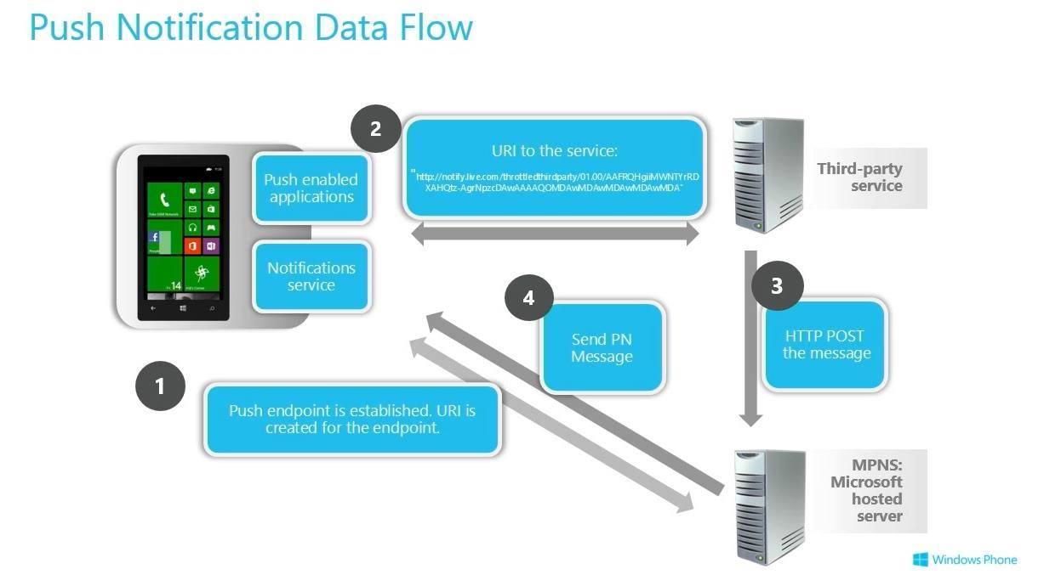

Description :

1. While running on the phone, the application creates an HttpNotificationChannel object, which provides a unique uniform resource identifier (URI) that uniquely identifies the phone where the application is installed and running.
2. The application then transmits the URI that identifies the phone to the entity that will initiate push notifications. In most cases, this entity is a web service created by the application developer.
3. The web service that initiates push notifications sends a specially crafted XML payload to the URI when a notification should be sent to the user phone. This delivers the notification to the Microsoft Push Notification Service for processing.
4. The Microsoft Push Notification Service detects when the user's phone has connectivity and sends pending notifications to the device. To optimize available bandwidth, these notifications might be sent in batches to the phone by the service.

# Reference

1. https://msdn.microsoft.com/en-us/library/hh221549.aspx